Environmental warming increases the importance of high-turnover energy channels in stream food webs

James R. Junker1,2,✉, Wyatt F. Cross1, James M. Hood3,4, Jonathan P. Benstead5, Alexander D. Huryn5, Daniel Nelson6, Jón S. Ólafsson7, and Gísli M. Gíslason8

1 Department of Ecology, Montana State University, Bozeman, MT 59717, USA  
2 Current address: Department of Biological Sciences, Advanced Environmental Research Institute, University of North Texas, Denton, TX 76203, USA  
3 The Aquatic Ecology Laboratory, Department of Evolution, Ecology, and Organismal Biology, The Ohio State University, Columbus, OH 43212, USA  
4 Translational Data Analytics Institute, The Ohio State University, Columbus, OH 43212, USA  
5 Department of Biological Sciences, University of Alabama, Tuscaloosa, AL 35487, USA  
6 National Aquatic Monitoring Center, Department of Watershed Sciences, Utah State University, Logan, UT 84322, USA  
7 Marine and Freshwater Institute, Hafnarfjördur, Iceland  
8 University of Iceland, Institute of Life and Environmental Sciences, Reykjavík, Iceland

✉ Correspondence: [James R. Junker <[james.junker@unt.edu](mailto:james.junker@unt.edu)>](mailto:james.junker@unt.edu)

Submission journal: Ecology

Submission type: Article

Open Research Statement: All data and code used in this work are publicly available and archived at Junker (2024) and Zenodo <https://zenodo.org/doi/10.5281/zenodo.10455904>.

Key words: climate change; energy flux; environmental filtering; food webs; species traits; temperature

# Abstract

Warming temperatures are altering communities and trophic networks across Earth’s ecosystems. While the overall influence of warming on food webs is often context-dependent, increasing temperatures are predicted to change communities in two fundamental ways: 1) by reducing average body size and 2) by increasing individual metabolic rates. These warming-induced changes have the potential to influence the distribution of food web fluxes, food web stability, and the relative importance of deterministic and stochastic ecological processes shaping community assembly. Here, we quantified patterns and the relative distribution of organic matter fluxes through stream food webs spanning a broad natural temperature gradient (5-27 $​^{∘}$ C). We then related these patterns to species and community trait distributions of mean body size and population biomass turnover (*P:B*) within and across streams. We predicted that 1) communities in warmer streams would exhibit smaller body size and higher *P:B* and 2) organic matter fluxes within warmer communities would increasingly skew towards smaller, higher *P:B* populations. Across the temperature gradient, warmer communities were characterized by smaller body size (~9% per $​^{∘}$ C) and higher *P:B* (~7% faster turnover per $​^{∘}$ C) populations on average. Additionally, organic matter fluxes *within* warmer streams were increasingly skewed towards higher *P:B* populations, demonstrating that warming can restructure organic matter fluxes in both an absolute and relative sense. With warming, the relative distribution of organic matter fluxes was decreasingly likely to arise through the random sorting of species, suggesting stronger selection for traits driving high turnover with increasing temperature. Our study suggests that a warming world will favor energy fluxes through ‘smaller and faster’ populations, and that these changes may be more predictable than previously thought.

# Introduction

Increasing global temperatures influence the provision and maintenance of ecosystem services by modifying the network of species interactions that underpin ecosystem functions (de Ruiter et al. 1995, Woodward et al. 2010, Brose et al. 2012, Thompson et al. 2012). Warming effects permeate across multiple levels of biological organization, from control on individual metabolic rates (Gillooly et al. 2001, Brown et al. 2004) and biological activity (e.g., attack rate, handling time, growth rates; Dell et al. 2014), to broad-scale shifts in community assembly and structure (Nelson et al. 2017b, Gibert 2019, Saito et al. 2021). Across global climate gradients, such temperature-induced changes have the potential to mediate food web stability (Baiser et al. 2019) by altering the acquisition and allocation of resources (Zhang et al. 2017) and the magnitude and relative distribution of energy fluxes in food webs (McCann et al. 1998, Gilbert et al. 2014, Barnes et al. 2018).

Understanding how warming alters energy flux in food webs requires information about how temperature modifies relationships between ecosystem structure and function. Such relationships depend upon how warming influences functional trait distributions and how functional traits translate to the magnitude and distribution of energy demands (Norberg et al. 2001, Loreau et al. 2001, Norberg 2004). Additionally, warming can modify community assembly processes (Saito et al. 2021)—both deterministic (e.g., environmental/niche filtering; Whittaker 1962) and stochastic (e.g., neutral theory; Hubbell 2001)—leading to many possible relationships between warming, the relative abundance of species, and dominance of particular functional traits. For example, although temperature appears to have minimal control on species richness across taxonomic groups (e.g., Bastazini et al. 2021), warming can have profound effects on the dominance structure (i.e., evenness) of ecological communities, often by reducing community evenness and favoring a reduced set of warm-adapted species (Hillebrand et al. 2008). This strong environmental filtering is likely to skew trait distributions in natural communities (Therriault and Kolasa 1999). However, the relative distribution of traits can be further modified by stochastic processes unrelated to environmental filtering (e.g., species interactions, Therriault and Kolasa 1999, demographic stochasticity, Hubbell 2001). The relative importance of these additional processes may increase with warming, as reduced population abundances (Bernhardt et al. 2018) and faster metabolic rates increase the possibility of local extirpation (Siqueira et al. 2020, Saito et al. 2021). The stochastic shifts in relative species abundances can either exaggerate or counter any skew in trait distributions driven by environmental filtering and thereby modify the relationship between species’ traits and the absolute and relative energy demands in food webs.

Body size is a fundamental trait that is influenced by temperature (for ectotherms see Atkinson 1994, Daufresne et al. 2009, and Gardner et al. 2011, also see Riemer et al. 2018 for deviations across endotherms) and has great potential to influence energy flux. Reduced body size in response to warming can arise at multiple levels of organization, including increased relative abundance of smaller species in warmed communities (Bergmann 1848), smaller individuals in warmer populations (James 1970), or reduced absolute body size of warmed individuals (Atkinson 1994). Thus, warmer communities are likely to contain both smaller species and individuals. These relationships can have important implications for energy and material flux in ecosystems because body size is a strong determinant of species life-history patterns (Peters 1983, Altermatt 2010, Zeuss et al. 2017, Nelson et al. 2020a), as well as developmental (Angilletta et al. 2004) and metabolic rates (Gillooly et al. 2001, Brown et al. 2004).

Metabolic rate, in addition to being controlled by body size, is another key trait that is influenced by temperature and tied to variation in energy flux through food webs (Gillooly et al. 2001, Barnes et al. 2018). Warming can influence metabolic rates indirectly through reductions in body size, as well as directly through its effects on subcellular kinetics (Osmond et al. 2017, Bideault et al. 2019). These processes can modify ecosystem patterns through changes in population carrying capacity (Bernhardt et al. 2018) and species relative abundances, with consequent effects on consumer-resource interactions or food web structure (Bideault et al. 2019, Gibert 2019). Moreover, metabolic rates are also tied to many biological processes (Dell et al. 2014), including growth rate (Gillooly et al. 2001), developmental rate (Zuo et al. 2012, Nelson et al. 2020a), voltinism (Zeuss et al. 2017), and biomass turnover rate (Brown et al. 2004, Huryn and Benke 2007). Taken together, these effects suggest that warming should lead to a smaller, faster world in which ecosystem processes accelerate through the effects of smaller body size and higher turnover rates, with a potentially strong imprint on food web structure and energy fluxes (Gibert 2019).

Here, we address two overarching and open questions focused on temperature effects on food web dynamics. First, how does ecosystem temperature shape the relationship between organic matter (OM) fluxes and community-level trait distributions, specifically body size and biomass turnover, across ecosystems? Second, how does temperature shape the role of deterministic vs. stochastic sorting processes in driving relative fluxes of OM through consumer communities? We quantified patterns of OM flux in stream food webs across a natural temperature gradient (~5–27 $​^{∘}$ C) in southwestern Iceland. Previous research in these streams has shown a strong positive effect of warming on primary production both among streams (Demars et al. 2011, Padfield et al. 2017) and seasonally within streams (O’Gorman et al. 2012, Hood et al. 2018). Due to high light levels and minimal OM inputs from surrounding terrestrial habitat, invertebrates in these streams rely on autochthonous production (O’Gorman et al. 2012, Nelson et al. 2020b); thus, the dynamics of in-stream primary production act as a strong control on energy flow through consumers (Junker et al. 2020). Due to the positive relationship of primary production with temperature, we predicted that annual OM fluxes to consumers would increase with stream temperature, mirroring patterns in resource availability. We also hypothesized that temperature would act as a principal environmental filter on community assembly and OM fluxes by favoring ‘fast’ life-history traits associated with small-bodied organisms. Specifically, we predicted that warming temperatures would lead to reduced average body size and increased average biomass turnover (i.e., *Production:Biomass* or *P:B* ratio) of populations among streams. We also predicted that *within* communities, OM fluxes would be skewed towards small-bodied and high *P:B* taxa at higher temperatures, and that these patterns would not arise by random sorting, but instead through ‘non-random ordering’, suggesting deterministic filtering of species traits. Our results should help refine general predictions about how ongoing climate warming, and its influence on key traits, is likely to shape energy flux through food webs dominated by ectotherms.

# Methods

We studied six streams within the Hengill geothermal field of southwestern Iceland (64 $​^{∘}$ 03’N 21 $​^{∘}$ 18’W) that varied in mean annual temperature from ~5 to 27 $​^{∘}$ C. Hengill is characterized by indirect geothermal heating of groundwater (Árnason et al. 1969), leading to natural variability in stream temperatures (4.5–54.0 $​^{∘}$ C), but similar solute chemistries (Friberg et al. 2009). These conditions create a “natural laboratory” for isolating the effects of temperature on ecosystem processes (O’Gorman et al. 2014, Nelson et al. 2017b). We selected streams to maximize the temperature range, while minimizing differences in the structural aspects of the primary producer community (Junker et al. 2021). However, this did lead to an unequal distribution of streams along the temperature gradient with three streams concentrated in the cooler temperature ranges. In each stream, we measured temperature and water depth every 15 min from July 2010 through August 2012 (U20-001-01 water-level logger, Onset Computer Corp., Pocasset, MA, USA).

## Invertebrate sampling

We sampled macroinvertebrate communities approximately monthly in six streams, four from July 2011 to August 2012 and two from October 2010 to October 2011 (*n* = 6 streams). The two streams sampled from 2010–2011 were part of a separate warming manipulation but data for this study were collected during the un-manipulated reference period (Nelson et al. 2017a, 2017b). Inter-annual comparisons of primary and secondary production in previous studies showed minimal differences among years in un-manipulated streams, suggesting that combining data from different years would not significantly bias our results (Nelson et al. 2017a, Hood et al. 2018). We collected five Surber samples (0.023 m2, 250-m mesh) from randomly selected locations within each stream encompassing all habitat types. Within the sampler, inorganic substrates were disturbed to ~10 cm depth and invertebrates and organic matter were removed from stones with a brush. Samples were then preserved with 5% formaldehyde until laboratory analysis. In the laboratory, we split samples into coarse (>1 mm) and fine (>250 $μ$ m–<1 mm) fractions using nested sieves and then removed invertebrates from each fraction under a dissecting microscope (10–15 $×$ magnification). For particularly large samples, fine fractions were sub-sampled (1/2–1/16th) using a modified Folsom plankton splitter prior to removal of invertebrates. Macroinvertebrates were identified to the lowest practical taxonomic level (usually genus) with taxonomic keys (Peterson 1977, Merritt et al. 2008, Andersen et al. 2013). Taxon-specific abundance and biomass were scaled to a per-meter basis by dividing by the Surber sampler area.

## Secondary production

Daily secondary production of invertebrate taxa was calculated using the instantaneous growth rate method (IGR, Benke and Huryn 2017). Growth rates were determined using taxon-appropriate approaches described in Junker and others (2020). Briefly, growth rates of common taxa (e.g., Chironomidae spp., *Radix balthica*, etc.) were measured using *in situ* chambers (Huryn and Wallace 1986). Multiple individuals (*n* = 5–15) within small size categories (~1-mm length range) were photographed next to a field micrometer, placed in the stream within pre-conditioned chambers for 7–15 days, and removed and photographed. Individual lengths were measured from field pictures using image analysis software (Schindelin et al. 2012), and body lengths were converted to mass (mg ash-free dry mass [AFDM]) using published length-mass regressions (Benke et al. 1999, O’Gorman et al. 2012, Hannesdóttir et al. 2013). Growth rates (*g*, d-1) were calculated from changes in mean body size (*M*) over a given time interval (*t*) with the following equation:

$$g=log_{e}\left(M_{t+Δt}/M_{t}\right)/Δt \left(1\right)$$

Variability in growth rates was estimated by bootstrapping through repeated resampling of individual lengths with replacement (*n* = 1000). For taxa that exhibit synchronous growth and development (e.g., Simuliidae spp., some Chironomidae spp., etc.), we examined temporal changes in length-frequency distributions and calculated growth rates and uncertainty using a bootstrap technique similar to that described in Benke and Huryn (2017). Individual lengths were converted to mass (mg AFDM) using published length-mass regressions cited above, and size-frequency histograms were visually inspected for directional changes in body size through time. For each date, size-frequency distributions were resampled with replacement and growth rates estimated from equation 1. We prevented the calculation of negative growth rates by requiring $M_{t+Δt}$ > $M_{t}$. If this condition was not met after 10,000 resamplings, a minimum growth rate of 0.001 was used (<5% of total instances). To estimate growth rates of taxa for which growth could not be estimated empirically, we developed stream-specific growth rate models by constructing multivariate linear regressions of empirical growth rates against body size and temperature. To estimate uncertainty in production of each taxon, we used a bootstrapping technique that resampled measured growth rates, in addition to abundance and size distributions from individual samples. For each iteration, size-specific growth rates were multiplied by mean interval biomass for each size class and the number of days between sample dates to estimate size class-specific production. For each time interval, size classes were summed for each taxon to calculate total population-level interval production. Intervals were summed to estimate annual secondary production (g AFDM m-2 y-1).

## Organic matter consumption estimates

Organic matter fluxes (g AFDM m-2 y-1) through stream communities were calculated using the trophic basis of production method (TBP; Benke and Wallace 1980). Taxon-specific secondary production estimates were combined with diet proportions, diet-specific assimilation efficiencies, *AEi*, and net production efficiencies, *NPE* (e.g., McCullough 1975), to estimate consumption of organic matter. Consumer diets of numerically dominant taxa were quantified through direct inspection of gut contents from multiple individuals throughout the year. Removal and preparation of gut tracts followed the methods outlined in Rosi-Marshall and coauthors (2016). To estimate variability in diet compositions and to impute missing values for non-dominant taxa, we modeled the diet proportions within each stream using a hierarchical multivariate model (Fordyce et al. 2011, Coblentz et al. 2017). Here, diet proportions for food categories were modeled following a Dirichlet distribution with expected proportions in diet and a concentration parameter to estimate variability around this expectation. We accounted for the hierarchical data structure by fitting stream-specific random intercepts, as well as random intercept offsets for taxon nested within each stream. All models were specified in the Stan language (Stan Development Team 2019) using the *brms* package in R (Bürkner 2017). Further model details can be found in supporting information (Appendix S1). We estimated diet overlap within and across stream food webs by calculating diet overlap from 1000 independent draws from the posterior distributions of modeled diet estimates. Overlap was calculated with the ‘overlap()’ function in the *RInSp* package (Zaccarelli et al. 2013).

For each food category, *i*, diet proportions were multiplied by the gross growth efficiency ($GGE_{i}=AE_{i}*NPE$) to calculate the relative production attributable to each food category. The relative production from each food type was then multiplied by the interval-level production and finally divided by $GGE_{i}$ to estimate consumption of organic matter from each food category by each taxon (Benke and Wallace 1980). Consumption was calculated for each taxon during each sampling interval (typically ~1 month). Total interval consumption was calculated by summing across all taxa, while annual consumption was calculated by summing across all taxa and intervals. Variability in consumption estimates was estimated through a Monte Carlo approach, where bootstrapped vectors of secondary production for each taxon (see *Secondary production* methods above) were resampled and consumption was estimated with the TBP method using modeled diet proportions, diet-specific assimilation efficiencies, and net production efficiency. Variability in *AEi* was incorporated by resampling values from beta distributions fit to median and 2.5% and 97.5% percentiles for each diet item: diatoms = 0.30 (95% percentile interval [PI]: 0.24-0.36), filamentous and green algae = 0.30 (95% PI: 0.24-0.36), cyanobacteria = 0.10 (95% PI: 0.08-0.12), amorphous detritus = 0.10 (95% PI: 0.08-0.12), vascular and non-vascular plants (bryophytes) = 0.10 (95% PI: 0.08-0.12), and animal material = 0.70 (95% PI: 0.56-0.84; Welch 1968, Benke and Wallace 1980, 1997, Cross et al. 2007, 2011). Variability in *NPE* was incorporated by resampling values from an assumed beta distribution with median *NPE* = 0.45 (95% PI = 0.40-0.50). Further details can be found in supporting materials (Appendix S3: Section S1: Trophic basis of production workflow and assumptions). Beta distributions were fit in R (R Core Team 2022) using the ‘get.beta.par()’ function within the *rriskDistributions* package (Belgorodski et al. 2017).

## Quantifying the distribution of food web fluxes

### Evenness among taxa

To visualize and quantify the evenness of OM fluxes, $p$, among taxa within each stream, we constructed Lorenz curves (Lorenz 1905) on rank-ordered OM fluxes, such that in a community with $S$ species the relative OM flux of species *j*, $p_{j}$, is ordered $p_{1}≤p_{2}≤...p_{S}$. The Lorenz curve shows how a value, in this case OM flux, accumulates with an increasing cumulative proportion of taxa. In a community with an equal distribution of OM flux among taxa, the Lorenz curve is a straight diagonal line. Deviation from equality was calculated as the Gini coefficient (Gini 1921), normalized for differences in $S$ among streams, $G^{*}$ (Solomon 1975, Chao and Ricotta 2019):

$$G^{*}=\left(2\sum_{j=1}^{S}{i}p_{j}−2\right)/\left(S−1\right) \left(2\right)$$

where $G^{*}$ represents an index of relative evenness of OM fluxes bounded between zero and one; a value of one represents a community with equal proportion of total community OM flux for all species ($1/S$), and a value of zero represents a community in which the total OM flux is attributed to a single taxon.

### Distribution of OM fluxes in relation to taxa traits

We predicted that warming would favor taxa with smaller body size and higher biomass turnover rates and that OM fluxes would therefore be skewed towards small body size (*M*) and higher *P:B* at higher temperatures across and within communities. To assess the change in the average population trait values and potential for environmental filtering across communities, we used bootstrapped linear regressions between either mean population body size ($\overline{M}$) or biomass turnover ($\overline{P:B}$) of each stream community and mean annual temperature ($​^{∘}$ C). Here, 1,000 values of population *M* or *P:B* were resampled with replacement from population secondary production vectors (see *Secondary production* above) for each taxon within each stream. We calculated the mean body size or *P:B* of the populations within each stream by first calculating the mean annual body size or annual *P:B* for each taxon and then taking the median across all taxa. We then calculated the least squares estimate between loge-transformed $\overline{M}$ or $\overline{P:B}$ and mean annual temperature. Response variables were loge-transformed to conform to assumptions of linearity and normally distributed residual variation and the ordinary least squares estimate was calculated with the ‘lm()’ function in R.

To quantify how the distribution of organic matter fluxes were modified *within* communities and whether this modification was related to temperature, we assessed the extent to which the relative OM fluxes among taxa were skewed towards populations with lower or higher relative *M* or *P:B*. To do this, we ordered taxa based on within-stream rankings of annual population traits (i.e., *M*, *P:B*) and then calculated a measure of skewness, $Sk_{flux}$, based on quartiles of the distribution of OM fluxes in relation to taxon traits as:

$$Sk_{flux}=f_{Q0.75}−2f_{Q0.5}+f_{Q0.25}/f_{Q0.75}−f_{Q0.25} \left(3\right)$$

where $f_{Qx}$, is the cumulative flux at some quantile, $Qx$, of the community trait distribution. We chose this quantile-based formula over other parametric or moments-based approaches because it is well defined and requires no assumptions of the moments of the distribution (Groeneveld and Meeden 1984). We repeated this analysis for all estimates of OM flux used to calculate *M* and *P:B* in each stream community. Skewness coefficients range from -1 to 1, where -1 indicates that OM fluxes are skewed perfectly away from a trait while 1 indicates that higher relative fluxes are perfectly associated with higher trait values. To determine if the skewness of fluxes with *M* and *P:B* was related to mean annual stream temperature, we used bootstrapped beta regression with a simple transformation, $\left(Sk_{flux}+1\right)/2$, to meet the assumptions of the model and standardize values between 0 and 1. Model coefficients were back-transformed to estimate effect sizes.

To examine the extent to which temperature influenced the skew of OM flux among populations within each community, we quantified the probability of observing the skewed distributions in OM fluxes by random chance. The feasible range of skewness values within a community is inherently tied to the evenness of OM fluxes. This dependence on evenness can make it difficult to determine the importance of random versus ecological processes on the distribution of OM fluxes by comparison of raw skewness measures alone. We predicted that species $M$ and $P:B$ would be increasingly important traits structuring OM fluxes within a community and therefore warmer streams would exhibit highly skewed OM distributions that would be unlikely due to chance (i.e., ‘non-random ordering’). In contrast, cooler streams would exhibit OM fluxes with skew values that are more likely due to random chance (‘random ordering’), regardless of raw skewness values, suggesting other traits or processes govern the distribution of OM fluxes within their communities. To accomplish this, we first had to account for statistical constraints that restrict the range of possible outcomes (i.e., feasible set; Haegeman and Loreau 2008, Diaz et al. 2021), given the number of species and the relative distribution of OM fluxes within a community. We permuted a random subset of each stream community’s feasible set by randomly ordering species and calculating skewness in the cumulative distribution of annual OM fluxes 100,000 times in each stream. This permuted set allowed us to calculate the probability of observing the empirical skewness value, $Sk_{flux}$, compared to a random ordering given the distribution of relative OM flux. We assessed the likelihood of non-random ordering as the distance from the central mass of the random skew distributions within each stream. Therefore, communities in which OM fluxes are likely organized non-randomly are indicated by observed skew values near the tails of these random distributions.

# Results

## Community organic matter fluxes

Annual community OM fluxes mirrored patterns of secondary production reported previously (Junker et al. 2020). Organic matter flux to invertebrates varied ~45-fold among streams, from 3.9 (2.1 – 6.4; mean [95% Percentile interval]) to 176.7 (124.1–236.5) g AFDM $m^{−2}y^{−1}$ and was positively related to temperature (Figure 1A).

Differences in OM flux among streams were driven by variation in total energy demand rather than composition of consumed resources, as consumer diets were highly similar among streams (Appendix S1: Figure S1). Across all streams, community-level diets were dominated by diatoms (43.9%; 0%–75.8%), amorphous detritus (17.2%; 0%–32.2%), and green algae (13.3%; 0%–43%). Within streams, diet overlap ranged from 68% (65%–71%) to 75% (69%–79%) among invertebrate taxa. Among streams, diets were also highly similar with a mean overlap of 89% (85%–92%). Diet overlap based on pairwise comparisons among streams showed little difference and no clear relationship with temperature.

## Evenness of organic matter fluxes

In general, OM fluxes were unevenly distributed among taxa (Gini inequality coefficients ranged from 0.09 [0.07 – 0.11, 95% PI] to 0.29 [0.25 – 0.32]; Appendix S2: Table S1) and were dominated by insects in the families Simuliidae and Chironomidae, pulmonate snails (*Radix balthica*), and oligochaete worms (Figure 2A & B; Appendix S2: Figure S2). In absolute terms, ~85% of total OM flux was contributed by 2 to 10 taxa, which comprised only 3% to 29% of total taxon richness among streams. Although differences in evenness among streams were partially attributed to variation in taxon richness (range: 14 to 35), fluxes were still highly uneven after accounting for differences in richness (i.e., similar ‘Normalized’ Gini coefficients, Appendix S2: Table S1). As average stream temperature increased, OM fluxes shifted from dominance by Simuliidae in the coolest stream to Chironomidae and *R. balthica* at moderate temperatures (Figure 2A). In the warmest stream, where maximum temperatures can often approach ~40 $​^{∘}$ C, taxon richness was lowest and OM fluxes were dominated by oligochaete worms in the family Naididae, the chironomid *Cricotopus sylvestris*, and *R. balthica* (Figure 2A). Among-stream differences in evenness of OM fluxes were not clearly related to temperature (Appendix S2: Table S1).

## Organic matter fluxes in relation to body size and biomass turnover rate

Across stream communities, average population body size ($\overline{M}$; mg AFDM ind-1) decreased and average population biomass turnover rate (; y-1) increased with increasing temperature (Figure 1B & C). $\overline{M}$ decreased from 2.75 mg AFDM ind-1 (1.03 – 5.08; 95% PI) in the coldest stream to 0.10 mg AFDM ind-1 (0.08 – 0.13) in the warmest stream, corresponding to an -8.7% (-11.1 – -6.4) change in mean body size for every 1 $​^{∘}$ C increase in temperature (Figure 1B). $\overline{P:B}$ ratio increased from 4.4 y-1 (3.6 – 5.1) in the coldest stream to 35.5 y-1 (29.6 – 43.3) in the warmest stream corresponding to a 6.9% (6.1–7.9) increase in $\overline{P:B}$ ratio for every 1 $​^{∘}$ C increase (Figure 1C).

Within stream communities, there were diverse body size–OM flux relationships, with some streams showing greater relative OM flux through larger-bodied taxa (positive skew), others showing greater OM flux through smaller-bodied taxa (negative skew), and some that showed no size-related trend in OM flux (skew range: -1 to 0.56; Figure 3A & B). Skew estimates of OM fluxes in relation to body size showed little association with stream temperature except in the warmest stream, where fluxes were heavily skewed toward small-bodied taxa (Figure 3B). Similarly, skew in OM fluxes in relation to *P:B* ratios varied among streams, ranging from -0.4 to 1. In this case, OM fluxes to consumers skewed increasingly toward higher turnover (*P:B*) taxa with increasing temperature (Figure 4A & B).

We compared our skew estimates (i.e., $Sk_{flux}$) of OM flux based on ordered data (i.e., ordered from small to large *M* or low to high *P:B* ratios; Figure 3B and Figure 4B) to skew estimates based on randomly sorted data to detect whether OM fluxes through smaller and higher *P:B* taxa could be attributed to these traits instead of random community assembly processes. The probability of observing a similar or more extreme skew of OM fluxes in relation to body size was variable among streams and ranged from 0.34 (0.19–0.55; 95% PI) to 0.79 (0.07–0.96); there was little association between this probability and temperature (Figure 3C). In contrast, the probability of a similar or more extreme skew in relation to *P:B* ratios ranged from 0.06 (0–0.75) to 0.62 (0.23–0.81; Figure 4C) and in this case there was a clear trend towards a more structured OM flux distribution—i.e., fluxes through high *P:B* taxa were favored at higher temperatures. The likelihood of higher relative fluxes among high *P:B* taxa became much higher with warming, and the probability of random ordering decreased by -4.6% (-5.1%—4.2%) for every 1 $​^{∘}$ C increase in temperature (Figure 4C).

# Discussion

While a growing body of theoretical and empirical research has enhanced our knowledge of temperature-mediated changes to ecosystems (e.g., O’Connor et al. 2009), general patterns remain elusive and empirical studies often show idiosyncratic outcomes (Nelson et al. 2017a, Zhang et al. 2017), especially at higher levels of biological organization (Walther et al. 2002, Woodward et al. 2010). Here, we demonstrate that warming acts as a strong environmental filter of species traits along a wide natural gradient of ecosystem temperatures. In particular, we found that increasing temperatures were associated with reduced population body size and increased population biomass turnover among stream invertebrate communities, leading to higher organic matter fluxes through these populations. In addition, we found that higher temperatures systematically skewed OM fluxes *within* communities, such that OM flows were increasingly dominated by taxa with rapid life-cycles. Lastly, we discovered that the distribution of fluxes within communities was non-random, especially with respect to *P:B* ratios at moderate to high temperatures, suggesting that temperature was especially important in structuring relative performance and resource acquisition within warm communities. These patterns show that the acceleration of energy and material fluxes through ecosystems in both an absolute (among ecosystems) and relative (within ecosystems) sense may be a general effect of environmental warming.

## Across-stream trends in community $\overline{P:B}$ and $\overline{M}$

Warming-induced shifts in community body size distributions were associated with a community-level increase in the absolute rates of material flux. At the community level, we observed a ~7% increase in the mean biomass turnover rate (*P:B*; y-1) of populations for each 1 $​^{∘}$ C of warming. Although this effect among communities may be partially attributed to the thermodynamic influence of temperature (Gillooly et al. 2001), biomass turnover rate is also closely related to organism body size (Brown et al. 2004, Huryn and Benke 2007). Thus, warming may influence the distributions of *P:B* ratios directly through its effects on metabolic rate and indirectly through reductions in organism body size and associated life-history traits. The increase in *P:B* we observed across communities was similar in magnitude to the reduction in body size (i.e., +7% vs –9%, respectively), reinforcing the fundamental connection between organism body size and *P:B*, but also suggesting increases in mean population *P:B* across communities may, in part, be attributed to reduced organism body sizes (Figure 1B & C). Organism body size is related to a number of other ecological attributes (Peters 1983) and changes in body size with increasing temperatures are likely to have broad implications for ecosystems in a changing climate (Gibert 2019).

A general reduction in body size has been deemed a “universal” response to warming (Daufresne et al. 2009, Gardner et al. 2011, Uszko et al. 2022), but notable deviations exist across ecosystems (Thresher et al. 2007, O’Gorman et al. 2012, Ohlberger 2013). Based on our monthly sampling over a full annual cycle, we observed a clear decrease in the average body size of populations from cool to warm communities (Figure 1B), corresponding to a ~9% decline in the mass of individuals for every 1 $​^{∘}$ C increase in temperature. While this change is based on community-level shifts (i.e., different sets of taxa), the magnitude of decline is consistent with intra-taxon patterns measured across broad phylogenetic groups (Deutsch et al. 2022). Interestingly, our results contrast with a warming experiment conducted in one of our study streams showing that a relatively small increase in temperature (3 $​^{∘}$ C) shifted invertebrate community biomass and productivity from smaller to larger organisms (Nelson et al. 2017a, 2017b). Moreover, an additional study at Hengill that examined community size spectra across a much broader range of body sizes and taxonomic groups (i.e., diatoms to fish), but with limited temporal sampling (i.e., August only), reported an unexpected shallowing of mass-abundance slopes, suggesting warming may favor larger-bodied individuals (Adams et al. 2013, O’Gorman et al. 2017). Other studies have reported similar deviations from the “universal” response for other taxonomic groups (e.g., invertebrates: Zeuss et al. 2017, birds: Geist 1987, Riemer et al. 2018, fish: Rypel 2014). While there is a strong propensity for reduced body size with warming, clearly many processes can modify the direction and magnitude of body size shifts and how they play out from individual to ecosystem levels (e.g., growth and developmental rates, resource supply, competition, predation; Ohlberger 2013). In addition, it is evident that the range of temperatures and body sizes considered, as well as the temporal scale of sampling, is likely to influence our understanding of how temperature influences patterns of body size in ecosystems (Jennings et al. 2007).

## Relative OM fluxes in relation to species trait distributions

In addition to the cross-ecosystem effects of temperature on patterns of species traits and organic matter flux, we found that temperature had strong effects on the relative performance of species *within* communities, leading to an increase in OM fluxes through populations with high biomass turnover rates. Generally speaking, OM fluxes were unevenly distributed among populations within communities, which may be expected given the systematic unevenness in the distribution of individuals among species (Diaz et al. 2021). However, we found important residual structure in the unevenness of OM fluxes that appeared to be related to functional trait axes. With respect to body size, the results were somewhat equivocal. In the coldest and warmest streams, we saw a strong skew in material fluxes towards larger and smaller species, respectively, but this pattern was not apparent at moderate temperatures (~6–17 $​^{∘}$ C). In contrast, we found a much clearer pattern with respect to biomass turnover rates, in which OM fluxes were increasingly skewed towards taxa with high turnover within warmer streams. We also found that this pattern was clearly non-random, suggesting that it is not likely to have arisen from stochastic, neutral processes alone (e.g., Hubbell 2001, Shoemaker et al. 2020). These results suggest that temperature may be a strong environmental filter—and therefore natural selection agent—for taxa with high turnover rates and associated life-history traits (e.g., multi-voltinism: Zeuss et al. 2017, Nelson et al. 2020a, short lifespan: Munch and Salinas 2009, Stoks et al. 2014, high growth rate: Donhauser et al. 2020), especially at relatively high temperatures.

## Warming and resource interactions

The ecological and evolutionary effects of warming are likely mediated by their interaction with food resource availability and dynamics (Cross et al. 2015, McMeans et al. 2015). In high-latitude ecosystems where light plays a dominant role in driving resource dynamics, consumer energy demands may be affected by resources more than by temperature *per se* (Huryn and Benstead 2019, Junker et al. 2020). This may be particularly apparent in open-canopied streams where primary production is highly synchronous with seasonal light regimes. Under such conditions, simplified resource dynamics may create strong selection for high growth and turnover rates (and associated *r*-selected life-history traits, such as small body size) because consumers cannot compensate for periods of resource scarcity through diet shifts (e.g., consumptive “portfolio” effects, Gutgesell et al. 2022). Future warming may exaggerate these effects because ectotherms may experience increased temperature-driven energy demands that are increasingly decoupled from resource availability (Huryn and Benstead 2019). Acknowledging these dynamics may lead to a more general framework for understanding different responses to warming across organisms (Greyson-Gaito et al. 2023), latitudes (Gibert 2019), and ecosystem types (McMeans et al. 2015, Gutgesell et al. 2022).

## Conclusions

We documented the important role of temperature in structuring key functional traits and the relative distribution of material fluxes across a natural stream temperature gradient. Higher temperatures were associated with increased total flux through the food web, as well as reductions in average population body size and increases in population biomass turnover. Further, biomass turnover rate—but less so body size—was increasingly important for structuring OM fluxes at warmer temperatures. Our results support the idea that warming may reduce organism size and also ‘speed up’ ecosystem dynamics in both an absolute and relative sense. These changes have important implications for the maintenance of biodiversity, as well as for the connections between biodiversity and the magnitude and stability of ecosystem energy and material cycles in a warming world.

# Acknowledgements

We are grateful to Sigurður Guðjónsson, Guðni Guðbergsson, and the staff at the Veiðimálastofnun for providing laboratory space and logistical support. We are also grateful to Sveinbjörn Steinþorsson at the University of Iceland for super-jeep transport to our field sites during the winter. We thank Lauren David, David Hernandez, Amanda Keasberry, Elena Nava, Camille Perrett, Jackie Pitts, Friðþjófur Árnason, Liliana García, Ragnahildur Magnúsdottír, Ryan McClure, Vija Pelekis, Adam Toomey, Chau Tran, Brooke Weigel, Tanner Williamson and many undergraduate workers for field and laboratory help. Jeff Wesner and Abe Kanz generously provided R code and discussions on modeling diet proportions. We thank Dr. Victor Saito and one anonymous reviewer for constructive comments that improved the paper. This study was supported by the National Science Foundation (DEB-0949774 and DEB-1354624 to JPB and ADH and DEB-0949726 to WFC).

# Conflict of Interest

The authors have no conflict of interest to declare.

# References

Adams, G. L., D. E. Pichler, E. J. Cox, E. J. O’Gorman, A. Seeney, G. Woodward, and D. C. Reuman. 2013. [Diatoms can be an important exception to temperature–size rules at species and community levels of organization](https://doi.org/10.1111/gcb.12285). Global Change Biology 19:3540–3552.

Altermatt, F. 2010. [Climatic warming increases voltinism in European butterflies and moths](https://doi.org/10.1098/rspb.2009.1910). Proceedings of the Royal Society B: Biological Sciences 277:1281–1287.

Andersen, T., P. S. Cranston, and J. H. Epler. 2013. Chironomidae of the Holarctic region: Keys and diagnoses, Part 1. Media Tryck, Lund, Sweden.

Angilletta, M. J., Jr., T. D. Steury, and M. W. Sears. 2004. [Temperature, Growth Rate, and Body Size in Ectotherms: Fitting Pieces of a Life-History Puzzle](https://doi.org/10.1093/icb/44.6.498). Integrative and Comparative Biology 44:498–509.

Árnason, B., P. Theodorsson, S. Björnsson, and K. Saemundsson. 1969. [Hengill, a high temperature thermal area in Iceland](https://doi.org/10.1007/BF02596720). Bulletin Volcanologique 33:245–259.

Atkinson, D. 1994. Temperature and organism size: A biological law for ectotherms? Advances in ecological research 25:1–58.

Baiser, B., D. Gravel, A. R. Cirtwill, J. A. Dunne, A. K. Fahimipour, L. J. Gilarranz, J. A. Grochow, D. Li, N. D. Martinez, A. McGrew, T. Poisot, T. N. Romanuk, D. B. Stouffer, L. B. Trotta, F. S. Valdovinos, R. J. Williams, S. A. Wood, and J. D. Yeakel. 2019. [Ecogeographical rules and the macroecology of food webs](https://doi.org/10.1111/geb.12925). Global Ecology and Biogeography 28:1204–1218.

Barnes, A. D., M. Jochum, J. S. Lefcheck, N. Eisenhauer, C. Scherber, M. I. O’Connor, P. de Ruiter, and U. Brose. 2018. [Energy Flux: The Link between Multitrophic Biodiversity and Ecosystem Functioning](https://doi.org/10.1016/j.tree.2017.12.007). Trends in Ecology & Evolution 33:186–197.

Bastazini, V. A. G., N. Galiana, H. Hillebrand, M. Estiarte, R. Ogaya, J. Peñuelas, U. Sommer, and J. M. Montoya. 2021. [The impact of climate warming on species diversity across scales: Lessons from experimental meta-ecosystems](https://doi.org/10.1111/geb.13308). Global Ecology and Biogeography 30:1545–1554.

Belgorodski, N., M. Greiner, K. Tolksdorf, and K. Schueller. 2017. rriskDistributions: Fitting Distributions to Given Data or Known Quantiles.

Benke, A. C., and A. D. Huryn. 2017. Secondary production and quantitative food webs. Pages 235–254 Methods in Stream Ecology. Elsevier.

Benke, A. C., A. D. Huryn, L. A. Smock, and J. B. Wallace. 1999. [Length-Mass Relationships for Freshwater Macroinvertebrates in North America with Particular Reference to the Southeastern United States](https://doi.org/10.2307/1468447). Journal of the North American Benthological Society 18:308–343.

Benke, A. C., and J. B. Wallace. 1980. [Trophic Basis of Production Among Net-Spinning Caddisflies in a Southern Appalachian Stream](https://doi.org/10.2307/1937161). Ecology 61:108–118.

Benke, A. C., and J. B. Wallace. 1997. [Trophic Basis of Production Among Riverine Caddisflies: Implications for Food Web Analysis](https://doi.org/10.1890/0012-9658(1997)078[1132:TBOPAR]2.0.CO;2). Ecology 78:1132–1145.

Bergmann, C. 1848. Über die Verhältnisse der Wärmeökonomie der Thiere zu ihrer Grösse.

Bernhardt, J. R., J. M. Sunday, and M. I. O’Connor. 2018. [Metabolic Theory and the Temperature-Size Rule Explain the Temperature Dependence of Population Carrying Capacity](https://doi.org/10.1086/700114). The American Naturalist:000–000.

Bideault, A., M. Loreau, and D. Gravel. 2019. [Temperature Modifies Consumer-Resource Interaction Strength Through Its Effects on Biological Rates and Body Mass](https://doi.org/10.3389/fevo.2019.00045). Frontiers in Ecology and Evolution 7.

Brose, U., J. A. Dunne, Montoya José M., O. L. Petchey, F. D. Schneider, and U. Jacob. 2012. [Climate change in size-structured ecosystems](https://doi.org/10.1098/rstb.2012.0232). Philosophical Transactions of the Royal Society B: Biological Sciences 367:2903–2912.

Brown, J. H., J. F. Gillooly, A. P. Allen, V. M. Savage, and G. B. West. 2004. [Toward a Metabolic Theory of Ecology](https://doi.org/10.1890/03-9000). Ecology 85:1771–1789.

Bürkner, P.-C. 2017. [Brms: An R Package for Bayesian Multilevel Models Using Stan](https://doi.org/10.18637/jss.v080.i01). Journal of Statistical Software 80:1–28.

Chao, A., and C. Ricotta. 2019. [Quantifying evenness and linking it to diversity, beta diversity, and similarity](https://doi.org/10.1002/ecy.2852). Ecology 100:e02852.

Coblentz, K. E., A. E. Rosenblatt, and M. Novak. 2017. [The application of Bayesian hierarchical models to quantify individual diet specialization](https://doi.org/10.1002/ecy.1802). Ecology 98:1535–1547.

Cross, W. F., C. V. Baxter, K. C. Donner, E. J. Rosi-Marshall, T. A. Kennedy, R. O. Hall, H. A. W. Kelly, and R. S. Rogers. 2011. [Ecosystem ecology meets adaptive management: Food web response to a controlled flood on the Colorado River, Glen Canyon](https://doi.org/10.1890/10-1719.1). Ecological Applications 21:2016–2033.

Cross, W. F., J. M. Hood, J. P. Benstead, A. D. Huryn, and D. Nelson. 2015. [Interactions between temperature and nutrients across levels of ecological organization](https://doi.org/10.1111/gcb.12809). Global Change Biology 21:1025–1040.

Cross, W. F., J. B. Wallace, and A. D. Rosemond. 2007. [Nutrient Enrichment Reduces Constraints on Material Flows in a Detritus-Based Food Web](https://doi.org/10.1890/06-1348.1). Ecology 88:2563–2575.

Daufresne, M., K. Lengfellner, and U. Sommer. 2009. [Global warming benefits the small in aquatic ecosystems](https://doi.org/10.1073/pnas.0902080106). Proceedings of the National Academy of Sciences 106:12788–12793.

de Ruiter, P. C., A.-M. Neutel, and J. C. Moore. 1995. [Energetics, Patterns of Interaction Strengths, and Stability in Real Ecosystems](https://doi.org/10.1126/science.269.5228.1257). Science 269:1257–1260.

Dell, A. I., S. Pawar, and V. M. Savage. 2014. [Temperature dependence of trophic interactions are driven by asymmetry of species responses and foraging strategy](https://doi.org/10.1111/1365-2656.12081). Journal of Animal Ecology 83:70–84.

Demars, B. O. L., J. R. Manson, J. S. Ólafsson, G. M. Gíslason, R. Gudmundsdóttir, G. Woodward, J. Reiss, D. E. Pichler, J. J. Rasmussen, and N. Friberg. 2011. [Temperature and the metabolic balance of streams](https://doi.org/10.1111/j.1365-2427.2010.02554.x). Freshwater Biology 56:1106–1121.

Deutsch, C., J. L. Penn, W. C. E. P. Verberk, K. Inomura, M.-G. Endress, and J. L. Payne. 2022. [Impact of warming on aquatic body sizes explained by metabolic scaling from microbes to macrofauna](https://doi.org/10.1073/pnas.2201345119). Proceedings of the National Academy of Sciences 119:e2201345119.

Diaz, R. M., H. Ye, and S. K. M. Ernest. 2021. [Empirical abundance distributions are more uneven than expected given their statistical baseline](https://doi.org/10.1111/ele.13820). Ecology Letters n/a.

Donhauser, J., P. A. Niklaus, J. Rousk, C. Larose, and B. Frey. 2020. [Temperatures beyond the community optimum promote the dominance of heat-adapted, fast growing and stress resistant bacteria in alpine soils](https://doi.org/10.1016/j.soilbio.2020.107873). Soil Biology and Biochemistry 148:107873.

Fordyce, J. A., Z. Gompert, M. L. Forister, and C. C. Nice. 2011. [A Hierarchical Bayesian Approach to Ecological Count Data: A Flexible Tool for Ecologists](https://doi.org/10.1371/journal.pone.0026785). PLOS ONE 6:e26785.

Friberg, N., J. B. Dybkjær, J. S. Olafsson, G. M. Gislason, S. E. Larsen, and T. L. Lauridsen. 2009. [Relationships between structure and function in streams contrasting in temperature](https://doi.org/10.1111/j.1365-2427.2009.02234.x). Freshwater Biology 54:2051–2068.

Gardner, J. L., A. Peters, M. R. Kearney, L. Joseph, and R. Heinsohn. 2011. [Declining body size: A third universal response to warming?](https://doi.org/10.1016/j.tree.2011.03.005) Trends in Ecology & Evolution 26:285–291.

Geist, V. 1987. [Bergmann’s rule is invalid](https://doi.org/10.1139/z87-164). Canadian Journal of Zoology.

Gibert, J. P. 2019. [Temperature directly and indirectly influences food web structure](https://doi.org/10.1038/s41598-019-41783-0). Scientific Reports 9:5312.

Gilbert, B., T. D. Tunney, K. S. McCann, J. P. DeLong, D. A. Vasseur, V. Savage, J. B. Shurin, A. I. Dell, B. T. Barton, C. D. G. Harley, H. M. Kharouba, P. Kratina, J. L. Blanchard, C. Clements, M. Winder, H. S. Greig, and M. I. O’Connor. 2014. [A bioenergetic framework for the temperature dependence of trophic interactions](https://doi.org/10.1111/ele.12307). Ecology Letters 17:902–914.

Gillooly, J. F., J. H. Brown, G. B. West, V. M. Savage, and E. L. Charnov. 2001. [Effects of size and temperature on metabolic rate](https://doi.org/10.1126/science.1061967). Science (New York, N.Y.) 293:2248–2251.

Gini, C. 1921. [Measurement of Inequality of Incomes](https://doi.org/10.2307/2223319). The Economic Journal 31:124–126.

Greyson-Gaito, C. J., G. Gellner, and K. S. McCann. 2023. [Life-history speed, population disappearances and noise-induced ratchet effects](https://doi.org/10.1098/rspb.2022.2149). Proceedings of the Royal Society B: Biological Sciences 290:20222149.

Groeneveld, R. A., and G. Meeden. 1984. [Measuring Skewness and Kurtosis](https://doi.org/10.2307/2987742). The Statistician 33:391.

Gutgesell, M. K., K. S. McCann, G. Gellner, K. Cazelles, C. J. Greyson-Gaito, C. Bieg, M. M. Guzzo, C. P. K. Warne, C. A. Ward, R. F. O’Connor, A. M. Scott, B. C. Graham, E. J. Champagne, and B. C. McMeans. 2022. [On the Dynamic Nature of Omnivory in a Changing World](https://doi.org/10.1093/biosci/biab144). BioScience 72:416–430.

Haegeman, B., and M. Loreau. 2008. [Limitations of entropy maximization in ecology](https://doi.org/10.1111/j.1600-0706.2008.16539.x). Oikos 117:1700–1710.

Hannesdóttir, E. R., G. M. Gíslason, J. S. Ólafsson, Ó. P. Ólafsson, and E. J. O’Gorman. 2013. [Increased Stream Productivity with Warming Supports Higher Trophic Levels](https://doi.org/10.1016/B978-0-12-417199-2.00005-7). Advances in Ecological Research 48:285–342.

Hillebrand, H., D. M. Bennett, and M. W. Cadotte. 2008. [Consequences of dominance: A review of evenness effects on local and regional ecosystem processes](https://doi.org/10.1890/07-1053.1). Ecology 89:1510–1520.

Hood, J. M., J. P. Benstead, W. F. Cross, A. D. Huryn, P. W. Johnson, G. M. Gíslason, J. R. Junker, D. Nelson, J. S. Ólafsson, and C. Tran. 2018. [Increased resource use efficiency amplifies positive response of aquatic primary production to experimental warming](https://doi.org/10.1111/gcb.13912). Global Change Biology 24:1069–1084.

Hubbell, S. P. 2001. The unified neutral theory of biodiversity and biogeography. Princeton University Press.

Huryn, A. D., and A. C. Benke. 2007. Relationship between biomass turnover and body size for stream communities. Body size: the structure and function of aquatic ecosystems. Cambridge University Press, Cambridge, UK:55–76.

Huryn, A. D., and J. P. Benstead. 2019. [Seasonal changes in light availability modify the temperature dependence of secondary production in an Arctic stream](https://doi.org/10.1002/ecy.2690). Ecology 100:e02690.

Huryn, A. D., and J. B. Wallace. 1986. [A method for obtaining in situ growth rates of larval Chironomidae (Diptera) and its application to studies of secondary production](https://doi.org/10.4319/lo.1986.31.1.0216). Limnology and Oceanography 31:216–221.

James, F. C. 1970. [Geographic Size Variation in Birds and Its Relationship to Climate](https://doi.org/10.2307/1935374). Ecology 51:365–390.

Jennings, S., J. a. a. D. Oliveira, and K. J. Warr. 2007. [Measurement of body size and abundance in tests of macroecological and food web theory](https://doi.org/10.1111/j.1365-2656.2006.01180.x). Journal of Animal Ecology 76:72–82.

Junker, J. 2024, January. [Jimjunker1/Junker_temperature-energy-flux](https://doi.org/10.5281/zenodo.10455905). Zenodo.

Junker, J. R., W. F. Cross, J. P. Benstead, A. D. Huryn, J. M. Hood, D. Nelson, G. M. Gíslason, and J. S. Ólafsson. 2020. [Resource supply governs the apparent temperature dependence of animal production in stream ecosystems](https://doi.org/10.1111/ele.13608). Ecology Letters 23:1809–1819.

Junker, J. R., W. F. Cross, J. P. Benstead, A. D. Huryn, J. M. Hood, D. Nelson, G. M. Gíslason, and J. S. Ólafsson. 2021. [Flow is more Important than Temperature in Driving Patterns of Organic Matter Storage and Stoichiometry in Stream Ecosystems](https://doi.org/10.1007/s10021-020-00585-6). Ecosystems 24:1317–1331.

Loreau, M., S. Naeem, P. Inchausti, J. Bengtsson, J. P. Grime, A. Hector, D. U. Hooper, M. A. Huston, D. Raffaelli, B. Schmid, D. Tilman, and D. A. Wardle. 2001. [Biodiversity and Ecosystem Functioning: Current Knowledge and Future Challenges](https://doi.org/10.1126/science.1064088). Science 294:804–808.

Lorenz, M. O. 1905. [Methods of Measuring the Concentration of Wealth](https://doi.org/10.2307/2276207). Publications of the American Statistical Association 9:209.

McCann, K., A. Hastings, and G. R. Huxel. 1998. [Weak trophic interactions and the balance of nature](https://doi.org/10.1038/27427). Nature 395:794–798.

McCullough, D. A. 1975. [Bioenergetics of three aquatic insects determined by radioisotopic analyses](https://doi.org/10.2172/7299553).

McMeans, B. C., K. S. McCann, M. Humphries, N. Rooney, and A. T. Fisk. 2015. [Food Web Structure in Temporally-Forced Ecosystems](https://doi.org/10.1016/j.tree.2015.09.001). Trends in Ecology & Evolution 30:662–672.

Merritt, R. W., K. W. Cummins, and M. B. Berg, editors. 2008. An Introduction to the Aquatic Insects of North America. 4th edition. Kendall/Hunt Publishing Co., Dubuque, IA.

Munch, S. B., and S. Salinas. 2009. [Latitudinal variation in lifespan within species is explained by the metabolic theory of ecology](https://doi.org/10.1073/pnas.0900300106). Proceedings of the National Academy of Sciences 106:13860–13864.

Nelson, D., J. P. Benstead, A. D. Huryn, W. F. Cross, J. M. Hood, P. W. Johnson, J. R. Junker, G. M. Gíslason, and J. S. Ólafsson. 2017a. [Shifts in community size structure drive temperature invariance of secondary production in a stream-warming experiment](https://doi.org/10.1002/ecy.1857). Ecology 98:1797–1806.

Nelson, D., J. P. Benstead, A. D. Huryn, W. F. Cross, J. M. Hood, P. W. Johnson, J. R. Junker, G. M. Gíslason, and J. S. Ólafsson. 2017b. [Experimental whole-stream warming alters community size structure](https://doi.org/10.1111/gcb.13574). Global Change Biology 23:2618–2628.

Nelson, D., J. P. Benstead, A. D. Huryn, W. F. Cross, J. M. Hood, P. W. Johnson, J. R. Junker, G. M. Gíslason, and J. S. Ólafsson. 2020b. [Thermal niche diversity and trophic redundancy drive neutral effects of warming on energy flux through a stream food web](https://doi.org/10.1002/ecy.2952). Ecology.

Nelson, D., J. P. Benstead, A. D. Huryn, W. F. Cross, J. M. Hood, P. W. Johnson, J. R. Junker, G. M. Gíslason, and J. S. Ólafsson. 2020a. [Contrasting responses of black fly species (Diptera: Simuliidae) to experimental whole-stream warming](https://doi.org/10.1111/fwb.13583). Freshwater Biology 65:1793–1805.

Norberg, J. 2004. [Biodiversity and ecosystem functioning: A complex adaptive systems approach](https://doi.org/10.4319/lo.2004.49.4_part_2.1269). Limnology and Oceanography 49:1269–1277.

Norberg, J., D. P. Swaney, J. Dushoff, J. Lin, R. Casagrandi, and S. A. Levin. 2001. [Phenotypic diversity and ecosystem functioning in changing environments: A theoretical framework](https://doi.org/10.1073/pnas.171315998). Proceedings of the National Academy of Sciences 98:11376–11381.

O’Connor, M. I., M. F. Piehler, D. M. Leech, A. Anton, and J. F. Bruno. 2009. [Warming and Resource Availability Shift Food Web Structure and Metabolism](https://doi.org/10.1371/journal.pbio.1000178). PLOS Biology 7:e1000178.

O’Gorman, E. J., J. P. Benstead, W. F. Cross, N. Friberg, J. M. Hood, P. W. Johnson, B. D. Sigurdsson, and G. Woodward. 2014. [Climate change and geothermal ecosystems: Natural laboratories, sentinel systems, and future refugia](https://doi.org/10.1111/gcb.12602). Global Change Biology 20:3291–3299.

O’Gorman, E. J., D. E. Pichler, G. Adams, J. P. Benstead, H. Cohen, N. Craig, W. F. Cross, B. O. L. Demars, N. Friberg, G. M. Gíslason, R. Gudmundsdóttir, A. Hawczak, J. M. Hood, L. N. Hudson, L. Johansson, M. P. Johansson, J. R. Junker, A. Laurila, J. R. Manson, E. Mavromati, D. Nelson, J. S. Ólafsson, D. M. Perkins, O. L. Petchey, M. Plebani, D. C. Reuman, B. C. Rall, R. Stewart, M. S. A. Thompson, and G. Woodward. 2012. [Impacts of Warming on the Structure and Functioning of Aquatic Communities](https://doi.org/10.1016/B978-0-12-398315-2.00002-8). Pages 81–176 Advances in Ecological Research. Elsevier.

O’Gorman, E. J., L. Zhao, D. E. Pichler, G. Adams, N. Friberg, B. C. Rall, A. Seeney, H. Zhang, D. C. Reuman, and G. Woodward. 2017. [Unexpected changes in community size structure in a natural warming experiment](https://doi.org/10.1038/nclimate3368). Nature Climate Change 7:659–663.

Ohlberger, J. 2013. [Climate warming and ectotherm body size – from individual physiology to community ecology](https://doi.org/10.1111/1365-2435.12098). Functional Ecology 27:991–1001.

Osmond, M. M., M. A. Barbour, J. R. Bernhardt, M. W. Pennell, J. M. Sunday, and M. I. O’Connor. 2017. [Warming-Induced Changes to Body Size Stabilize Consumer-Resource Dynamics](https://doi.org/10.1086/691387). The American Naturalist 189:718–725.

Padfield, D., C. Lowe, A. Buckling, R. Ffrench-Constant, S. Jennings, F. Shelley, J. S. Ólafsson, and G. Yvon-Durocher. 2017. [Metabolic compensation constrains the temperature dependence of gross primary production](https://doi.org/10.1111/ele.12820). Ecology Letters 20:1250–1260.

Peters, R. H. 1983. [The ecological implications of body size](https://doi.org/10.1017/CBO9780511608551). Cambridge University Press, Cambridge.

Peterson, B. V. 1977. Black flies of Iceland (Diptera-Simuliidae). Canadian Entomologist 109:449–472.

R Core Team. 2022. R: A Language and Environment for Statistical Computing. R Foundation for Statistical Computing, Vienna, Austria.

Riemer, K., R. P. Guralnick, and E. P. White. 2018. [No general relationship between mass and temperature in endothermic species](https://doi.org/10.7554/eLife.27166). eLife 7:e27166.

Rosi-Marshall, E. J., H. A. Wellard Kelly, R. O. Hall, and K. A. Vallis. 2016. [Methods for quantifying aquatic macroinvertebrate diets](https://doi.org/10.1086/684648). Freshwater Science 35:229–236.

Rypel, A. L. 2014. [The Cold-Water Connection: Bergmann’s Rule in North American Freshwater Fishes](https://doi.org/10.1086/674094). The American Naturalist 183:147–156.

Saito, V. S., D. M. Perkins, and P. Kratina. 2021. [A Metabolic Perspective of Stochastic Community Assembly](https://doi.org/10.1016/j.tree.2021.01.003). Trends in Ecology & Evolution:S0169534721000057.

Schindelin, J., I. Arganda-Carreras, E. Frise, V. Kaynig, M. Longair, T. Pietzsch, S. Preibisch, C. Rueden, S. Saalfeld, B. Schmid, J.-Y. Tinevez, D. J. White, V. Hartenstein, K. Eliceiri, P. Tomancak, and A. Cardona. 2012. [Fiji: An open-source platform for biological-image analysis](https://doi.org/10.1038/nmeth.2019). Nature Methods 9:676–682.

Shoemaker, L. G., L. L. Sullivan, I. Donohue, J. S. Cabral, R. J. Williams, M. M. Mayfield, J. M. Chase, C. Chu, W. S. Harpole, A. Huth, J. HilleRisLambers, A. R. M. James, N. J. B. Kraft, F. May, R. Muthukrishnan, S. Satterlee, F. Taubert, X. Wang, T. Wiegand, Q. Yang, and K. C. Abbott. 2020. [Integrating the underlying structure of stochasticity into community ecology](https://doi.org/10.1002/ecy.2922). Ecology 101:e02922.

Siqueira, T., V. S. Saito, L. M. Bini, A. S. Melo, D. K. Petsch, V. L. Landeiro, K. T. Tolonen, J. Jyrkänkallio-Mikkola, J. Soininen, and J. Heino. 2020. [Community size can affect the signals of ecological drift and niche selection on biodiversity](https://doi.org/10.1002/ecy.3014). Ecology 101.

Solomon, D. L. 1975. A comparative approach to species diversity. Page 7. Technical {{Report}}, Biometrics Unit, Cornell University, Ithaca, NY USA.

Stan Development Team. 2019. Stan Modeling Language Users Guide and Reference Manual.

Stoks, R., A. N. Geerts, and L. De Meester. 2014. [Evolutionary and plastic responses of freshwater invertebrates to climate change: Realized patterns and future potential](https://doi.org/10.1111/eva.12108). Evolutionary Applications 7:42–55.

Therriault, T. W., and J. Kolasa. 1999. Physical determinants of richness, diversity, evenness and abundance in natural aquatic microcosms. Oecologia 412:123–130.

Thompson, R. M., U. Brose, J. A. Dunne, R. O. Hall, S. Hladyz, R. L. Kitching, N. D. Martinez, H. Rantala, T. N. Romanuk, D. B. Stouffer, and J. M. Tylianakis. 2012. [Food webs: Reconciling the structure and function of biodiversity](https://doi.org/10.1016/j.tree.2012.08.005). Trends in Ecology & Evolution 27:689–697.

Thresher, R. E., J. A. Koslow, A. K. Morison, and D. C. Smith. 2007. [Depth-mediated reversal of the effects of climate change on long-term growth rates of exploited marine fish](https://doi.org/10.1073/pnas.0610546104). Proceedings of the National Academy of Sciences 104:7461–7465.

Uszko, W., M. Huss, and A. Gårdmark. 2022. [Smaller species but larger stages: Warming effects on inter- and intraspecific community size structure](https://doi.org/10.1002/ecy.3699). Ecology 103:e3699.

Walther, G.-R., E. Post, P. Convey, A. Menzel, C. Parmesan, T. J. C. Beebee, J.-M. Fromentin, O. Hoegh-Guldberg, and F. Bairlein. 2002. [Ecological responses to recent climate change](https://doi.org/10.1038/416389a). Nature 416:389–395.

Welch, H. E. 1968. [Relationships between Assimiliation Efficiencies and Growth Efficiencies for Aquatic Consumers](https://doi.org/10.2307/1935541). Ecology 49:755–759.

Whittaker, R. H. 1962. [Classification of natural communities](https://doi.org/10.1007/BF02860872). The Botanical Review 28:1–239.

Woodward, G., J. P. Benstead, O. S. Beveridge, J. Blanchard, T. Brey, L. E. Brown, W. F. Cross, N. Friberg, T. C. Ings, U. Jacob, S. Jennings, M. E. Ledger, A. M. Milner, J. M. Montoya, E. O’Gorman, J. M. Olesen, O. L. Petchey, D. E. Pichler, D. C. Reuman, M. S. A. Thompson, F. J. F. Van Veen, and G. Yvon-Durocher. 2010. [Ecological Networks in a Changing Climate](https://doi.org/10.1016/B978-0-12-381363-3.00002-2). Pages 71–138 Advances in Ecological Research. Elsevier.

Zaccarelli, N., D. I. Bolnick, and G. Mancinelli. 2013. [RInSp: An r package for the analysis of individual specialization in resource use](https://doi.org/10.1111/2041-210X.12079). Methods in Ecology and Evolution 4:1018–1023.

Zeuss, D., S. Brunzel, and R. Brandl. 2017. [Environmental drivers of voltinism and body size in insect assemblages across Europe](https://doi.org/10.1111/geb.12525). Global Ecology and Biogeography 26:154–165.

Zhang, L., D. Takahashi, M. Hartvig, and K. H. Andersen. 2017. [Food-web dynamics under climate change](https://doi.org/10.1098/rspb.2017.1772). Proceedings of the Royal Society B: Biological Sciences 284:20171772.

Zuo, W., M. E. Moses, G. B. West, C. Hou, and J. H. Brown. 2012. [A general model for effects of temperature on ectotherm ontogenetic growth and development](https://doi.org/10.1098/rspb.2011.2000). Proceedings of the Royal Society B: Biological Sciences 279:1840–1846.

# Figure captions

Figure 1. (a) Total organic matter flux (g AFDM m-2 y-1) increased with mean annual temperature. Higher stream temperatures also led to (b) a decrease in mean population body size (, mg ind-1) and (c) an increase in mean population biomass turnover rate (, y-1). For all panels, points represent the mean value, wide bars represent the 25th and 75th percentile bounds, narrow bars represent the 2.5th and 97.5th percentile bounds, and grey lines show a random sample of bootstrapped linear models (n = 400).

Figure 2. (a) Percent contribution of taxa to OM flux (loge[g AFDM m-2 y-1])in each stream; colors correspond to mean annual temperature shown in the legend; (b) rank-ordered organic matter flux (loge[g AFDM m-2 y-1]) by taxon. Taxon abbreviations: F:Naid, Family Naididae; N comm, *Nais communis*; C syl, *Cricotopus sylvestris*; R balt, *Radix balthica*; Macro sp., *Macropelopia* sp.; C dent, *Chaetocladius dentiforceps*; S vitt, *Simulium vittatum*; Euk spp., *Eukiefferiella* spp.; O obl, *Orthocladius oblidens*; Micro sp. *Micropsectra* sp.; D bert, *Diamesa bertrami*; D boh-zer, *Diamesa bohemani-zernyi*; F: Lumb, Family Lumbricidae; P cing, *Potamophylax cingulatus*; S gland, *Sperchon glandulosus*; P urs, *Prosimulium ursinum*; SC: Cope, Subclass Copepoda; R eff, *Rheocricotopus effusus*; S vern, *Simulium vernum*; Chaet sp., *Chaetocladius* sp.; Thien sp., *Thienemanniella* sp.; O frig, *Orthocladius frigidus*; Limn rip, *Limnophora riparia*; Dicra, *Dicranota* sp.; C: Ost, Class Ostracoda; S aur, *Simulium aureum*. The number of taxa represented in the “Other” category for each stream is shown in the lower right corner of each panel.

Figure 3. (a) Lorenz curves showing cumulative relative organic matter flux among taxa with increasing body size (from left to right; *M*, mg AFDM ind-1). The solid line 1:1 line from the origin represents the line of equality. Distributions near this line suggest minimal structuring of OM fluxes in relation to body size. The dotted line allows for visualization of skewness in OM fluxes based on its intersection with the empirical Lorenz curve. (b) Empirical estimates of body size-related OM flux skewness in relation to stream temperature. (c) The probability of observing these skewness values when compared to a random ordering. For panels B and C, points represent the median value, wide bars represent the 25th and 75th percentile bounds, and narrow bars represent the 2.5th and 97.5th percentile bounds.

Figure 4. (a) Lorenz curves showing cumulative relative organic matter flux among taxa with increasing *P:B* ratio (from left to right; y-1). The solid 1:1 line from the origin represents the line of equality. Distributions near this line suggest minimal structuring of OM fluxes in relation to *P:B* ratio. The dotted line allows for visualization of skewness in OM fluxes based on its intersection with the Lorenz curve. (b) Estimates of *P:B*-related OM flux skewness in relation to stream temperature. (c) The probability of observing these skewness values when compared to a random (i.e., stochastic) ordering. For panels B and C, points represent the median value, wide bars represent the 25th and 75th percentile bounds, and narrow bars represent the 2.5th and 97.5th percentile bounds.

Figure 1

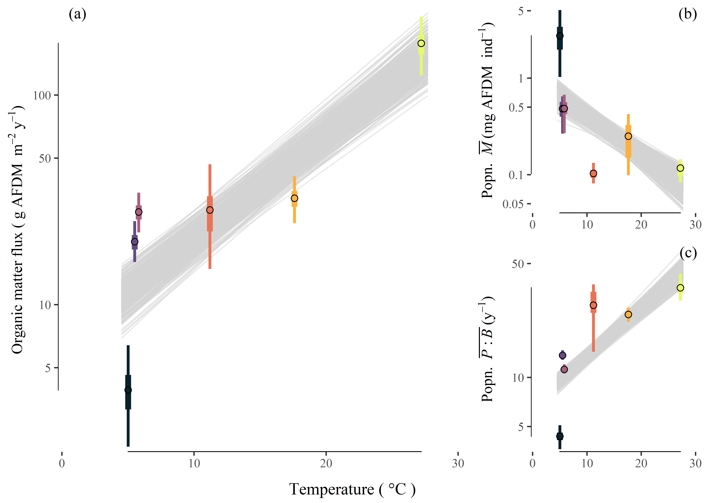

Figure 2

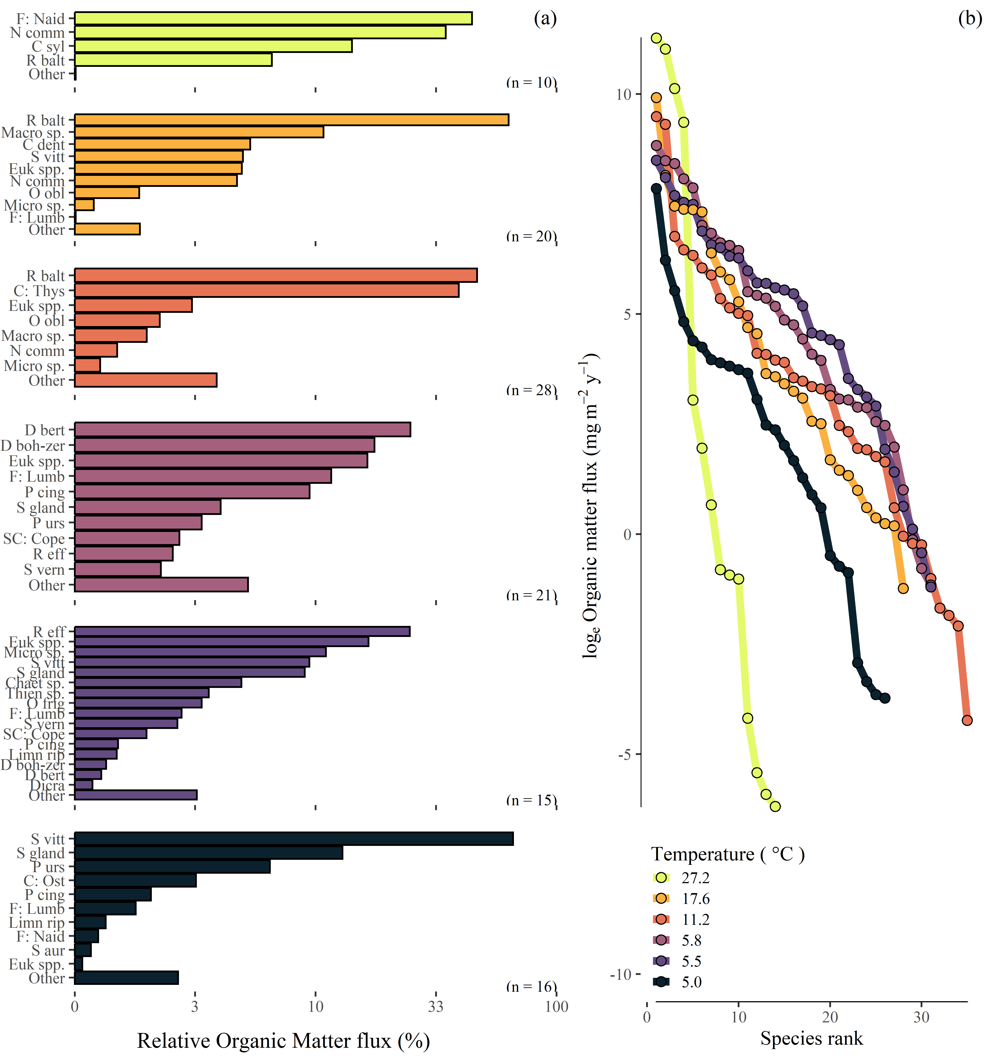

Figure 3

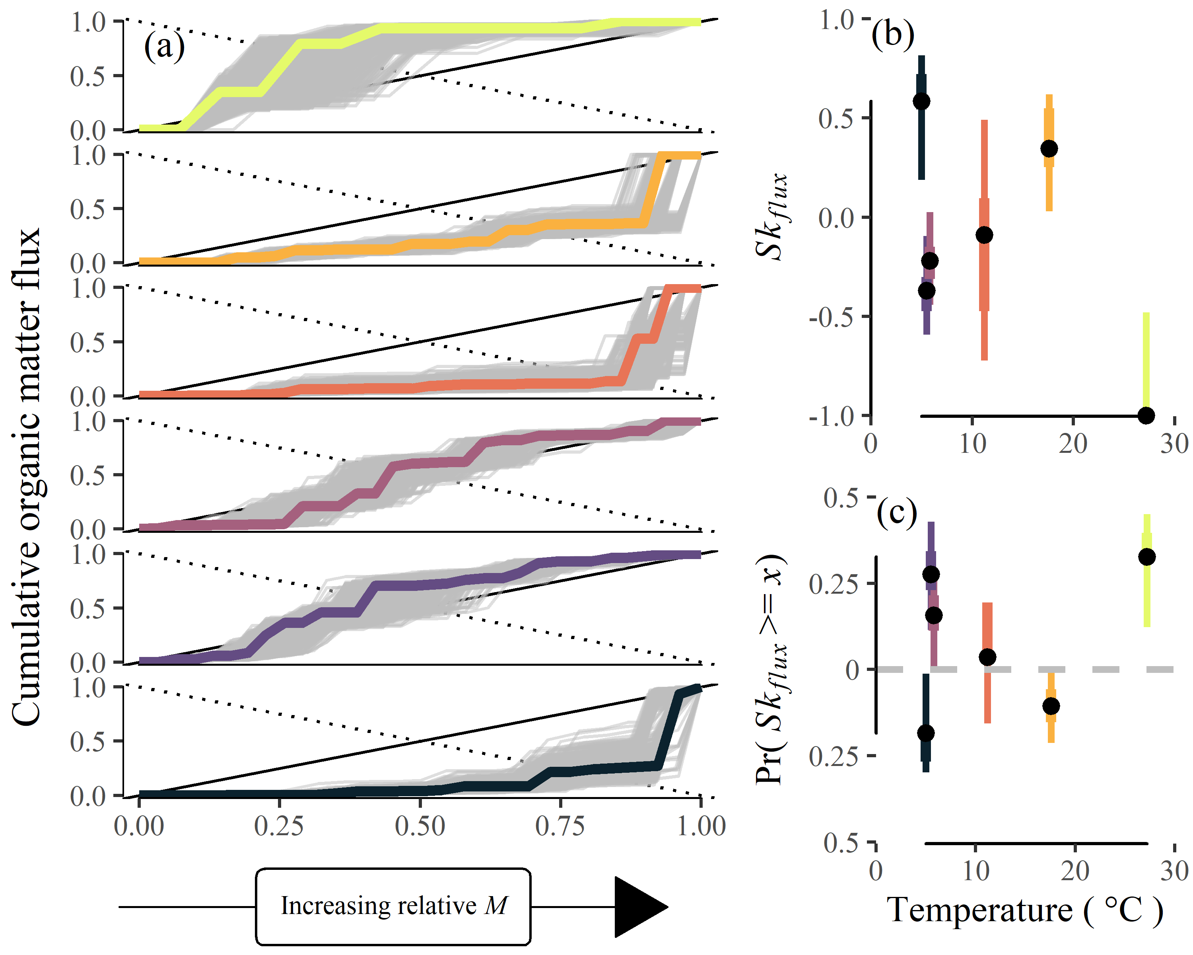

Figure 4

